RBSP EFW
Preamp OP15A TID
Test Report

RBSP_EFW_TR_005

David Curtis, U.C. Berkeley RBSP EFW Systems Engineer

Document Revision Record
Rev. | Date | Description of Change

Distribution List
Name | Email
David Curtis, Systems  Keith Goetz, PM  John Bonnell, Inst CoI  Ron Jackson, QA | dwc@ssl.berkeley.edu  goetz@umn.edu  jbonnell@ssl.berkeley.edu  ronj@ssl.berkeley.edu

TBDs
Identifier | Description

Reference Documents
Ref | Doc Number | Title

Overview
A Total Ionizing Dose radiation test was performed for the RBSP EFW project on five OP15AJ/883 (Lot Date Code 0114N) opamps at National Semiconductor Gamma cell 220 radiation facilities in Santa Clara, CA, on December 8, 2008. Opamps were tested at 20, 50, 80, and 100 krads (Si), and after 24 and 48 hour room temperature biased anneal, and finally after another 120 hours at 100C biased anneal. Some parametric changes were seen during test, some of which were reversed by anneal, while other parameters were worse after anneal. Some parameters were out of spec during the test and after anneal, and use of the part at these radiation levels depends on if those changes can be tolerated.

Test Procedure
The devices were characterized prior to radiation and immediately after each dose (and after the anneal periods) using the opamp characterization setup described in section 2.1. The units were biased during dosing at +/-15V (100mA limit) using the circuit shown in Figure 1. The 5 parts were radiated simultaneously, and the total supply current was monitored during the test – no significant change was seen. Radiation test facility records are included in Appendix B, showing dose levels and rates.

Figure 1 – Biasing circuit
Parts were radiated to 20, 50, 80, and 100krads, and characterized after each dose. They were then allowed to anneal and re-tested after 24 and 48 hours at room temperature, then after another 120 hours at +100C.

Opamp Characterization
At each step in testing the opamps were fully characterized using an LTS2020 test station with an LTS2100 Opamp family board and an LTS0614 low leakage socket adapter (calibrated Test Tech, 5/21/2008). This test station makes the following measurements (with the listed accuracies) and verifies the results are within the data sheet specifications. The values of the parameters are also recorded to look for any significant charges.

Test 1. V+ supply operating current
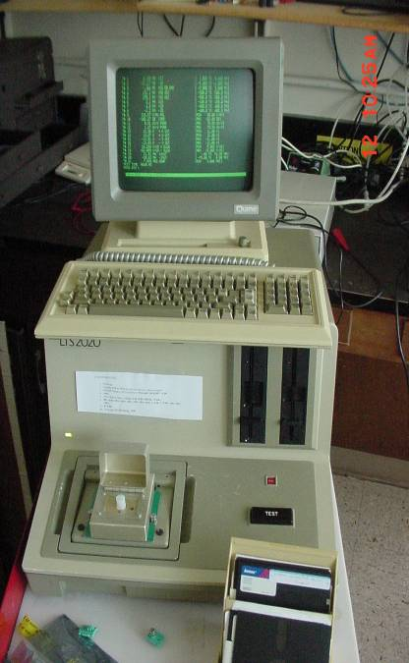
±0.2% + 10μA
Figure 7. LTS2020 OPAMP Tester
Test 2. V- supply operating current
±0.2% + 10μA
Test 3. Offset voltage
±0.25% + 5μV
Test 4. Offset Current
±5% + 25fA
Test 5. Bias Current
±5% + 25fA
Test 6. Large Signal Voltage Gain
±1.5% + 1V/mV
Test 7. Common Mode Rejection Ratio
±0.25% + 0.1dB
Test 8. Power Supply Rejection Ratio
±0.25% + 1μV/V
Test 9,10. Output Voltage Swing, 2kohm load
±0.4% + 1mV
Test 11,12. Output current source/sink
±0.2% + 10μA
Test 13,14. Slew Rate
±10%
Test 15. Gain Bandwidth Product.
±10% + 10kHz

Appendix A includes part of the OP15 data sheet showing the operating limits for comparison.

A control part (unit C) was measured prior to measurements of the TID test devices to verify that any change is not a result of a change in the LTS2020. Each unit was measured twice. All testing was done at room temperature.

The tester was initially set to measure within the data sheet limits. When a parameter exceeded those limits, the limits were expanded in order to measure the actual value without saturation.

Test Results
The units were all in spec prior to radiation dosing. After 20krads all 5 devices were out of spec for Ib and IOS, and continued to get worse with increasing radiation. As the test range increased, the resolution of the measurement got worse, eventually causing those parameters to read out of spec even for the control unit (which is artificial). After 100krads Ib reached almost to 1nA, while IOS reached 200pA (compared to a spec of 50pA and 10pA respectively). However, this effect dissipated during anneal, with all parts being back in spec (or very close to it) after anneal.

VOS also gradually increased with radiation, though less dramatically than Ib and IOS. Units 4 and 5 exceeded spec after 50krads, Unit 1 after 80krads, and units 2 and 3 after 100krads. A curious feature of the increase is that once it gets started (about the time it exceeds spec) it seems to step up each time it is measured independent of if it is being radiated (about the same increment each time). This continues through anneal until it reaches a limit, where it stays. All of the parts were stable after completing anneal, but were well out of spec (-18 to -32mV compared to a spec of +/-0.5mA). It is interesting that they all drifted in the same direction. My guess is that some part of the opamp characterization test was putting a small stress on the part, which had been somehow weakened by radiation. One possibility is the factory offset trimming circuit (Zener-zap), which may have been weakened by radiation such that the normal test cycle resulted in the trim circuit being activated. It is not clear if this problem would occur in normal operation. Without further testing it must be assumed that VOS will drift significantly with radiation.

No other parameter changed significantly or exceeded spec during radiation tests. However, as the VOS climbed during anneal a number of the small-signal parameters (AOL CMRR, PSRR) began to change, and eventually went out of spec. When the LTS2020 was adjusted to account for a larger offset voltage, the parameters recovered somewhat, though were still out of spec in some cases (CMRR of -69 to -75 dB compared to a limit of -86dB, and PSRR of 150-256 uV/V compared to a limit of 51 uV/V). These parameters measure small changes, which are biased by large offsets due to the large VOS values, and so may not be reliable measurements. The values changed with the VOS limit settings of the tester. Without further testing it must be assumed that CMRR and PSRR will be out of spec after radiation.

Detailed measurement results are presented in Appendix C. A value of ‘A’ in the table indicates the measurement was out of range.

Summary
To use these parts at 100krads one must tolerate VOS as high as 32mV, CMRR as high as -69dB, and PSRR as high as 256uV/V.

Appendix A – OP15 Data Sheet

Appendix B. Radiation Facility Records

Appendix C - OP15A Test Results

